Youtube Content Monetization Modeler – Miniproject 3

Project report
Jessica Sriramula

Introduction:
As video creators and media companies increasingly rely on platforms like YouTube for income, predicting potential ad revenue becomes essential for business planning and content strategy. My task is to build a Regression ML model after experimenting five different types of regression models and deciding based on accuracy the best ML model that can accurately estimate YouTube video ad revenue for individual videos based on various performance and contextual features, and implement the results in a simple streamlit web application.

Analysis:
For this project, I have written the python code for all the steps of the data analysis, visualisation and model analysis in VScode. Firstly, I have analysed the youtube ad revenue csv dataset file provided, by importing and reading the file in VScode, and utilised the pandas library. Then I have performed all the necessary EDA steps such as null values treatment(likes, comments and watch time minutes) – for this I have utilised the MICE imputation where a realistic number of values in the missing columns(likes, comments and watch time minutes) is added based on patterns found in the rest of the dataset through the IterativeImputer which uses machine learning to look at the healthy columns (like views) and calculates a highly realistic estimate for the missing data. For example, if a video has 500 views, the mice imputation will guess a matching, realistic number of likes and watch minutes based on patterns found in the rest of the dataset and add to the missing values in the dataset columns(likes, comments and watch time). Next I have also done the outlier detection where only the views column showed outliers, for this I have used the log transformation which compresses massive numbers (viral videos) and expands small numbers, transforming a heavily skewed curve into a normal, symmetric distribution. This prevents large view counts from completely dominating the regression weights. Next for feature engineering, I added more features that are necessary to the data analysis such as engagement rate, views to subscribers ratio, average view duration in mins and comment to like ratio. Next, utilised the one hot encoding method to convert the categorical values of the columns into numerical values so that ML models can understand category, device and country columns, also checked and removed duplicate values in the dataset, also checked for any relationships in the dataset and trends in the dataset through a linear graph which contribute to the overall youtube ad revenue and found out that watch time in minutes contributes linearly to the overall youtube ad revenue whereas the other columns in the dataset do not contribute in a positive manner to the overall youtube ad revenue also from the heatmap analysis. I have removed unwanted columns video_id which does not contribute to the ad revenue and I have updated the date column to include day of the week and is weekend column and month column. For this project, I utilised pandas, matplotlib, seaborn, numpy and sklearn mainly. After the entire cleaning of the data is done, I have stored the dataset into two separate files one for encoding the categorical columns which is named as youtube_ad_revenue_encoded and youtube_processed which is the completed cleaned dataset in VScode.
After this part, I have used five different ML models which are linear regression, random forest, ridge regression model, lasso regression model and random forest regression models to train and test the dataset variables(X,y) using the youtube_processed dataset which has been cleaned, and then calculated the accuracy metrics R2score, MAE and RMSE for each of the models and compared the accuracy metrics of each model, because the R2 score value, MAE and RMSE of the random forest model is 94.78%, $3.47 and $14.14 compared to the gradient boosting model which is 94.77%, $4.06, $14.16 etc as well as compared to the other models, so the best model to use here is the random forest model for estimating the youtube ad revenue overall, therefore I have implemented the random forest model into my streamlit application to predict and estimate the overall youtube video ad revenue based on total number of likes, comments, views, subscribers, country, device and category etc. Below is the findings, insights and interpretation of my streamlit app random forest model.

My streamlit application with the Random Forest Model:
Here is a screenshot of my streamlit application home page and revenue estimation page where I showcase my results of the ad revenue estimation.
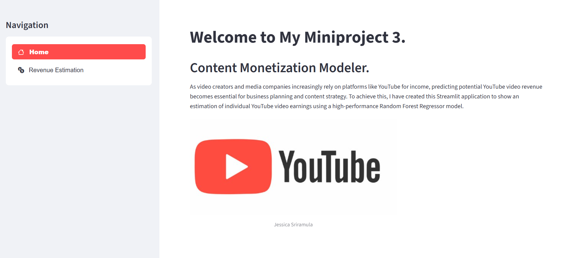
This is the homepage of my streamlit application.

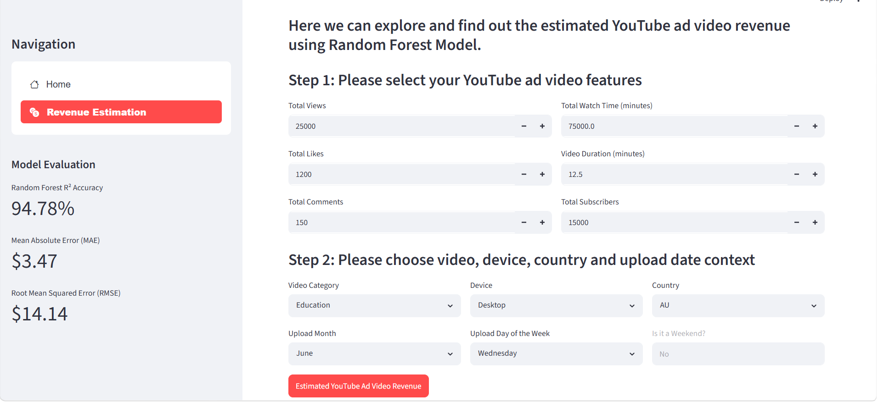
This is the revenue estimation page of my streamlit application which uses the random forest model after inputting all the youtube video ad features.

Findings, insights and interpretation of streamlit app model:
Note: here the education video is used as an example with the desktop as the device, AU as the country and january, monday as the weekday and month of the ad video upload to see what drives the estimated youtube ad revenue for these ad video features selected on the streamlit model page.
Total views | Total likes | Total comments | Total watch time | Video duration | Total subscribers | Video category | Device | Country | Upload month, weekday | Is  weekend | Estimated ad  revenue(usd)
1000  17,000  0  0  0  0  0  0  1000  1000  0  0  1000  1000  1000 | 0  0  20  1100  0  0  0  0  10  30  0  0  0  0  0 | 0  0  0  0  10  70  0  0  10  30  0  0  0  0  0 | 0  0  0  0  0  0  10  30  10  30  0  0  0  0  0 | 0  0  0  0  0  0  0  0  0  0  10  30  0  0  0 | 0  0  0  0  0  0  0  0  0  0  0  0  20  100  4200 | Education | desktop | AU | january, monday | no | $255.80  $250.23  $262.69  $263.54  $254.06  $251.14  $201.84  $201.84  $242.05  $245.41  $252.63  $222.86  $255.80  $255.80  $247.63

In conclusion:
From this analysis, I have found that the youtube ad revenue increases and decreases based on the video type, category chosen and also increases and decreases based on the device type used and the country as well, and also with the upload weekday/weekend and month, all the different video features can be further explored in the streamlit app model, here the example of education video type, desktop device type, AU as the country, monday as the weekday and january as the month is used to make a conclusion as to what drives the ad revenue by keeping some values as zero and increasing and decreasing the video ad features as shown in the table above.
From the table above, we can see that as the total views increases the ad revenue decreases this means that there is a decrease in ad revenue, we can also see that as the total likes increases the ad revenue also increases this means that there is an increase in ad revenue, as the total comments increases the ad revenue decreases this means that there is a decrease in ad revenue, the total watch time is dependent on the total likes and comments which means that if the likes and comments increase and the watch time also increases then the ad revenue also increases for the same number of total views, if the video duration increases then the ad revenue decreases this means that there is a decrease in ad revenue. We can also see that as the number of subscribers increases from twenty to hundred there is no increase or decrease in ad revenue for the same number of total views but when the number of subscribers increases to a very high value the ad revenue starts to decrease which tells us that a very high number of subscribers generates a decreased ad revenue.
Therefore, the main drivers of positive increased usd youtube ad revenue from my analysis above are total likes and total watch time where total watch time is dependent on total likes and comments.

